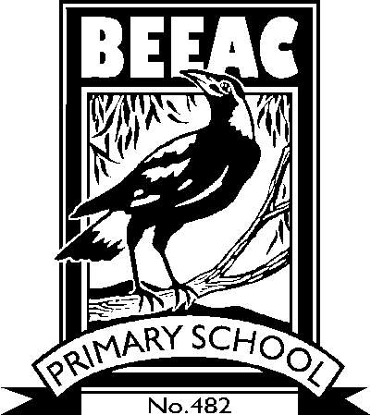
Beeac Primary School Code of Conduct
All staff, volunteers and School Council members of Beeac Primary School are required to observe child safe principles and expectations for appropriate behaviour towards and in the company of children, as noted below.
All personnel of Beeac Primary School are responsible for supporting the safety, participation, wellbeing and empowerment of children by:
- adhering to Beeac Primary School’s child safe policy at all times / upholding Beeac Primary School’s statement of commitment to child safety at all time
- taking all reasonable steps to protect children from abuse
- treating everyone with respect
- listening and responding to the views and concerns of children, particularly if they are telling you that they or another child has been abused and/or are worried about their safety or the safety of another
- promoting the cultural safety, participation and empowerment of Aboriginal children (for example, by never questioning an Aboriginal child’s self-identification)
- promoting the cultural safety, participation and empowerment of children with culturally and/or linguistically diverse backgrounds (for example, by having a zero tolerance of discrimination)
- promoting the safety, participation and empowerment of children with a disability (for example, during personal care activities)
- ensuring as far as practicable that adults are not left alone with a child
- reporting any allegations of child abuse to Beeac Primary School’s Child Safety Officer Andrew Rogers and ensure any allegation are reported to the police or child protection
- reporting any child safety concerns to Beeac Primary School’s Child Safety Officer Andrew Rogers.
- if an allegation of child abuse is made, ensure as quickly as possible that the child(ren) are safe
  - encouraging children to ‘have a say’ and participate in all relevant organisational activities where possible, especially on issues that are important to them.
Staff and volunteers must not:
- develop any ‘special’ relationships with children that could be seen as favouritism (for example, the offering of gifts or special treatment for specific children)
- exhibit behaviours with children which may be construed as unnecessarily physical (for example inappropriate sitting on laps. Sitting on laps could be appropriate sometime, for example while reading a storybook to a small child in an open plan area)
- put children at risk of abuse (for example, by locking doors)
- do things of a personal nature that a child can do for themselves, such as toileting or changing clothes
- engage in open discussions of a mature or adult nature in the presence of children (for example, personal social activities)
- use inappropriate language in the presence of children
- express personal views on cultures, race or sexuality in the presence of children
- discriminate against any child, including because of culture, race, ethnicity or disability
- have contact with a child or their family outside of our organisation without our child safety officer’s knowledge and/or consent (for example, no babysitting). Accidental contact, such as seeing people in the street, is appropriate)
- have any online contact with a child or their family (unless necessary, for example providing families with e-newsletters)
  - ignore or disregard any suspected or disclosed child abuse.
By observing these standards you acknowledge your responsibility to immediately report any breach of this code to Beeac Primary School’s Child Safety Officer Andrew Rogers.
If you believe a child is at immediate risk of abuse phone 000.
I agree to adhere to this Code of Conduct:

Name: ……………………………….............

Signature: ……………………………………

Date: ……………………………………........

Where the term ‘Aboriginal’ is used it refers to both Aboriginal and Torres Strait Islander peoples. Indigenous is retained when it is part of the title of a report, program or quotation. Throughout this paper we refer to ‘Aboriginal peoples’ rather than ‘Aboriginal people’ to reflect the plurality and diversity of Victorian Aboriginal communities.
Available at: www.dhs.vic.gov.au/about-the-department/documents-and-resources/policies,-guidelines-and-legislation/child-safe-standards

